Kauphusman et al.—Cottonmouth habitat selection.
Habitat Selection by Cottonmouths (Agkistrodon piscivorus) in a Hydrologically Dynamic Wetland
C.M. Gienger^{1,3}, John H. Kauphusman III¹, Michael C. Fulbright^{1,2}
¹Department of Biology and Center of Excellence for Field Biology, Austin Peay State University, Clarksville, TN 37040, USA
²Department of Biology, Cumberland University, Lebanon, TN 37087, USA
³Corresponding author: C.M. Gienger, email: giengerc@apsu.edu

Abstract.—Wetlands are often transitional habitats characterized by dynamic hydrologic gradients between terrestrial and aquatic systems. Fluctuating hydrologic conditions can create episodic resource scarcity, potentially favoring species that cope with environmental unpredictability through flexible habitat use or broad habitat preferences. We examined habitat selection of a population of Western Cottonmouths (Agkistrodon piscivorus) inhabiting a riverine slough in Middle Tennessee. Using visual-encounter surveys, we measured abiotic and biotic habitat characteristics at snake locations (N = 149) and compared them with random locations representing available habitat. Our results indicate that Cottonmouths select a diverse range of habitat features representing a subset of the available aquatic and terrestrial conditions. Habitat use did not differ between sexes but varied ontogenetically, with younger individuals selecting more terrestrial habitats with greater availability of cover objects. These findings suggest that Cottonmouths cope with the environmental variability of dynamic wetlands through flexible habitat use.

Key Words.—environmental disturbance; niche-overlap; ontogenetic shift; Random Forest; Western Cottonmouth

Introduction

Wetlands are productive and biologically diverse ecosystems that provide resources for a variety of wildlife species (Mitsch and Gosselink 2000). Wetlands are often transitional ecosystems that connect terrestrial and aquatic habitats, where fluctuations in underlying hydrology often influence the extent of the habitat availability and suitability (Brinson 1993). Wet-dry hydrologic fluctuations can cause wetlands to become periodically resource-limited, as areas become either flooded or dried (Brinson 1993). Fluctuations can be both seasonal and stochastic, causing some species to adopt shifting strategies of habitat use. Individuals may (1) choose to be selective and use wetland areas only when favorable conditions and resources are available, or (2) remain in wetlands even when conditions are not favorable and adopt a more generalized use of resources as the hydrological environment changes (Devictor et al. 2008; Poff and Zimmerman 2010). More specifically, heterogeneous environments with frequent disturbance regimes are often rapidly colonized and occupied by generalist species, whereas relatively homogeneous environments typically favor resource partitioning by specialist species (Macarthur and Wilson 1967; Adler and Wilson 1987; Fournier et al. 2015; Büchi and Vuilleumier 2016).
Just as environmental factors can shape ecological strategies, it is also important to understand how competition may play a role in determining habitat use (Greenbaum 2004; Mayor et al. 2009; Steen et al. 2014). Competitive exclusion shapes partitioning of resource use among species including use of habitats (Levin 1970; Amarasekare 2003). To avoid the limiting effects, inferior competitors tend to select resources not exploited by the superior, and thus competition may be an important factor in the evolution of ecological variation in habitat use (Bolnick 2004).
We sought to understand the habitat selection strategy of an isolated population of Cottonmouths found within a hydrologically-dynamic riverine slough. The Western Cottonmouth (Agkistrodon piscivorus) is a semi-aquatic pit viper commonly found in wetland associated habitats throughout the southeastern United States. Cottonmouths are dietary generalists, as they feed on a wide variety of prey, and have been found in many different aquatic habitats (Gloyd and Conant 1990; Ford et al. 2004; Hill and Beaupre 2008; McKnight et al. 2014; Lutterschmidt et al. 2022).
Cottonmouths are often found in high abundances (Ford 2002), and in stable seasonal-depressional wetland systems they have been found to have subtle ontogenetic, seasonal, and intersexual differences in habitat selection (Eskew et al. 2009; Delisle et al. 2019). Ontogenetic shifts in habitat use and diet are a common strategy to reduce competitive exclusion in reptiles (Vitt 2000; Shine et al. 2003), and intersexual differences in habitat use of pit-vipers are relatively common (Reinert 1984; Pearson et al. 2002). However, populations inhabiting highly dynamic environments such as those with high incidence of hydrologic disturbance and unpredictability in resource availability may experience reduced habitat specialization and substantial niche overlap (Marvier et al. 2004; Mason et al. 2011; Durso et al. 2013; Smith et al. 2018; Stireman and Singer 2018). Because Cottonmouths occupy a variety of wetland types, populations inhabiting heterogenous wetlands with hydrologic fluctuation should have habitat selection that is driven predominantly by local environmental variation rather than by biotic interactions such as competition and predation (Mason et al. 2011; Stireman and Singer 2018).
We hypothesized that Cottonmouths residing in riverine wetlands use generalist habitat selection as an adaptation to hydrologically-dynamic ecosystems, and predict extensive among-individual habitat niche overlap due to the temporal instability of available resources. To examine Cottonmouth habitat niche space and habitat selection, we (i) investigated the realized habitat niche space from comparisons of the available habitat within a transitional wetland gradient from aquatic to terrestrial areas, (ii) determined which environmental factors predicted the occurrence of Cottonmouths and (iii) determined whether there were intraspecific differences in habitat selection.

Materials and Methods

Study area.—Our study site was located along the Cumberland River, Cheatham County, Tennessee, USA (36˚17’ N, 87˚05’W). The site is a mixture of lowland forest, slough wetlands, upland limestone bluffs, and rocky outcrops. The site is bordered by limestone bluffs, backwater streams, the Cumberland River, and crop fields (Fig.1). These landscape features appear to somewhat isolate the population from dispersing to other adjacent areas along the Cumberland River, as previous telemetric studies have shown that snakes do not leave the approximately 76 ha wetland study area (Smith 2009; Fulbright 2014).
The study area is predominately Buttonbush (Cephalanthus occidentalis) slough (12.6 ha), seasonally-flooded lowland forest (20.9 ha), edge areas (15.4 ha), and upland forest (16.9 ha). Water depth in the buttonbush slough ranges from 50-250 cm with intermittently dispersed floating vegetation (Floating Pennywart, Hydrocotyle ranunculoides and Marsh Seedbox, Ludwigia palustris). The lowland forest is predominantly Red Maple (Acer rubrum), and functions as a transition area between the slough and upland forest containing limestone bluffs that serve as overwintering hibernacula. Edge areas are comprised of emergent vegetation that is occasionally inundated (<10 cm) throughout the year and the upland forest is dominated by oak trees (Quercus spp.) contributing to a thick duff layer overlying bare soil on the forest floor. Sycamore Creek flows into the slough from the upland forest and provides varying inflows of water, along with periodic flooding from the Cumberland River, and groundwater seepage. During seasonal rainfalls, the multiple points of inflow cause periodic flooding within the slough. Both the Cumberland River and Sycamore Creek follow a general trend of high flow in the early spring and low flows in the fall, although, both have stochastic flooding events associated with periods of high rainfall (Supplemental Fig. 1).
Field collection.—We conducted visual encounter surveys from April to October for three years (2013, 2014, & 2019). Teams of paired individuals waded or hiked haphazardly through the wetland and adjacent areas and visually scanned for coiled or outstretched (typically swimming) Cottonmouths. Surveys occurred over 2-3 hours in early morning or early evening periods, often extending until dusk. Survey paths were intentionally meandering, allowing researchers to thoroughly search available habitat features, scanning approximately 5 m on either side of the survey path. A typical survey crossed the entire wetland encompassing both aquatic and terrestrial areas. We captured snakes using tongs and retained captured individuals in plastic restraining tubes (Midwest Tongs, Greenwood, MO, USA). For individual identification, each snake was implanted subcutaneously with a Passive Integrated Transponder (PIT) tag (Biomark, Boise, ID, USA) on the ventral side, posterior to midbody. Tags and implant syringes were soaked in Benzalkonium Chloride (Benz-all; VetPro, Northfield, MN, USA) for 2 – 3 minutes prior to tag implantation, and an antiseptic liquid bandage (Vetclose, Portland, ME, USA) was applied to the injection site to facilitate healing. Snout-vent length (SVL) and tail lengths (TL) were measured, and snakes were sexed by either everting hemipenes or by probing (Blanchard and Finister 1933). Body mass was measured with a Pesola spring scale. Individuals were considered adults if their snout to vent length (SVL) was greater than 500 mm, individuals with an SVL between 300 – 500 mm were considered juveniles (Burkett 1966, Eskew et al. 2009), and neonates were considered to be individuals less than 300 mm SVL (Koons et al. 2009). Gravid females were not used in analysis due to known differences in habitat use while gravid (Delisle et al. 2019).
At the location in which the individuals were first sighted, we recorded a suite of biotic and abiotic habitat variables and identified different aspects of cover objects and vegetation (i.e., microhabitats; Table 1). We follow the definitions of Hall et al. (1997) and consider “habitat” to be the resources and conditions present in an area that influence species occupancy. A 1 m² quadrat frame was used to assess the components of sites selected by Cottonmouths (i.e., presence) compared to those available in the environment (i.e., pseudo-absence). To assess available habitat, each snake location was paired with a randomly chosen comparison site using a random compass bearing (read from the sweep-second hand of a wristwatch) and distance (1- 100 m) selected from a random numbers table. Random sites were assessed immediately after a snake was captured and processed.

Analysis of habitat selection: ecological niche.—The concept of the ecological niche was used as a framework to analyze the range of environmental variables available within the study area compared to those Cottonmouths selected (Reinert 1984; Litvak and Hansell 1990). To reduce multicollinearity from the environmental variables measured, we condensed surface and ambient temperature into a single mean temperature variable, leaving 16 environment variables for analysis (Table 1). We used Principal Component Analysis (PCA) on correlations to reduce dimensionality of the environmental variables. Each dimension (Principal Component axis) was ranked based on explained variance (Peres-Neto et al. 2003) and we retained the first three principal components for further analysis using the scree method on the eigenvalues (Jackson 1993). The scree method retains dimensions with eigenvalues that explain more variance than would be expected by chance. Specifically, eigenvalues for the dimensions that are above the mean eigenvalue score across all dimensions from PCA are retained, along with the subsequent dimension with an eigenvalue that is just below the mean (Jackson 1993). All statistical analyses were performed using R (R Core Team 2025) and plotted using the ggplot2 package (Wickham 2016). An alpha of 0.05 was used to judge statistical significance for all tests.
As PCA is predominantly a visual ordination technique, we additionally used a Permutational Multivariate Analysis of Variance (PERMANOVA; 9999 permutations) and Permutational Analysis of Multivariate Dispersion (PERMDISP; 9999 permutations) on Euclidean distances to determine whether Cottonmouth habitat selection was significantly different than that available in multivariate space. PERMANOVA tests for discrimination between groups within multivariate space. More specifically, PERMANOVA tests the null hypothesis that groups do not differ as a function of their distances between centroid locations, their relative dispersion of variance, or both (Anderson 2001), without assuming normality and homogeneity of variance (Delgado-Baquerizo et al. 2015). PERMDISP tests for homogeneity of multivariate dispersion among groups and is used to determine whether differences in dispersion are the primary cause of significance in the PERMANOVA test (Anderson et al. 2006; Assis et al. 2013). More specifically, PERMDISP tests the null hypothesis that dispersion is homogenous among groups in multivariate space (Anderson et al. 2006). PERMANOVA/PERMDISP tests were computed in R using the vegan package (Oksanen et al. 2026).

Analysis of habitat selection: intra-specific differences.—To test for intra-specific differences in habitat use, an ANOVA (Analysis of Variance) was used to compare conspecific group PCA scores (adult males, adult females, juveniles, and neonates) and was followed by Tukey’s HSD post-hoc tests. Linear regression was used to evaluate the presence of an ontogenetic shift in habitat use by comparing snake body size (SVL) with individual component scores on the first three PC-axes (Eskew et al. 2009).

Analysis of habitat selection: modeling habitat preference.—Random Forest (RF) classification (Breiman 2001) was used to identify the environmental variables that best predict Cottonmouth habitat selection. RF is a nonparametric classification method that builds an ensemble model based on a large set of decision trees. For each tree, a bootstrap sample of approximately 64% (i.e., bag sample) was used as a training set, and the remaining data withheld as a validation set (i.e., out-of-bag [OOB]) (Breiman 2001, Severson et al. 2017). RF uses all trees constructed within a model to predict and estimate the overall OOB error rate, which is treated as a metric of model accuracy (Breiman 2001, Cutler et al. 2007, Severson et al. 2017).
We constructed an optimal model for classifying habitat selection from the environmental variables by comparing sites of Cottonmouth occurrence to available habitat sites as pseudo-absences. We applied 30-iterations of RF models, using the randomForest package (Breiman et al. 2018), where each iteration used 6,000 decision trees on a 10-fold cross-validation training set. Next, a cross-validation test set was applied to calculate mean model accuracy and identify a minimal error rate model. To improve model performance, we ran the first RF model applying the Model Improvement Ratio (MIR; Murphy et al., 2010) technique to increase model parsimony by identifying the minimum number of variables to include. The model with the minimum number of variables and the minimum OOB error rate was selected for model iterations.
RF Model performance was evaluated by the minimum, maximum, and mean OOB accuracy from the 30-iterations. The independent validation set from cross validation was used to assess model accuracy, sensitivity, specificity, the area under the curve of a Receiver Operator Characteristic (AUC), and the Kappa statistic (Cutler et al. 2007). To assess the importance of each environmental variable in predicting Cottonmouth occurrences we used the minimal error rate model to produce relative variable importance values based on the Mean Decrease Accuracy (MDA). MDA is calculated as follows: for each tree, the initial prediction error on the OOB portion of the data is recorded, and then the OOB prediction error is permuted for each predictor variable. The difference between the initial prediction error and permuted prediction error is then averaged over all trees (Han et al. 2016). We used the MDA for variables classifying Cottonmouth selection to calculate relative importance in prediction of Cottonmouth occurrence for each environmental variable. We constructed partial dependence plots from the six most important environmental variables (~50% cumulative relative importance) to illustrate the predictive relationship of the environmental variables on cottonmouth occurrence.

Results

We surveyed 149 individual Cottonmouths and 174 habitat-comparison sites on 96 d over three-years (2013, 2014, & 2019) of field study and recorded sixteen environmental variables at each of these sites (n = 323). Captured individuals included 60 adult males, 39 adult females, 28 juveniles, and 22 neonates. Adult males averaged 744 ± (SD) 132 mm in SVL, adult females were 620 ± (SD) 60 mm, juveniles were 408 ± (SD) 55 mm, and neonates averages 251 ± (SD) 24 mm. During spring (April – May) we found 48 individuals during 20 surveys, 84 individuals during 64 summer surveys (June – August), and 17 individuals during 12 fall surveys (September – October).

Habitat selection: ecological niche.—The first three Principal Components describing Cottonmouth habitat use, collectively explained 43.7% of the variation within the environmental variable structure (Table 1). Environmental variables associated with PC-1 describe a terrestrial to aquatic gradient (Fig. 2), where distance to water (loading = 0.395), canopy closure (0.334), and leaf cover (0.328) were positively associated, and percent water (-0.459), water depth (-0.406), and floating/emergent vegetation (-0.351) were negatively associated. PC-2 described coarse woody habitat structure, contrasting distance to cover (-0.437), distance to water (-0.281), and leaf cover (-0.257) with log diameter (0.517) and fallen log cover (0.478). PC-3 described a gradient between vegetative and rocky cover, where vegetation cover (-0.556), cover height (-0.429), and woody stem height (-0.301) were negatively associated, and rock cover (0.410) was positive associated. Cottonmouths had broad preferences for sites within the wetland system along the aquatic-terrestrial gradient, and slight preference for sites with more cover objects (Fig. 2).
The PERMANOVA/PERMDISP tests found a difference between Cottonmouth habitat selection and available habitat within multivariate space (PERMANOVA; P= 0.001; Pseudo-F_{1,314} = 20.4). The results from the PERMDISP test showed that differences between Cottonmouth sites and available habitat sites were attributed to the heterogeneous distribution of variance of the environmental variables between the two groups, where Cottonmouth habitat was nested within the available habitat measured (PERMDISP; P<0.001; F_{1,314} = 25.02). The mean distance to centroid locations was 4.02 for available habitat, while Cottonmouth habitat was 3.26 (Fig. 2). The PERMANOVA/PERMDISP tests supported results of the PCA showing heterogeneous dispersion between selected habitat and available habitat features in the environment (Fig. 2). Specifically, the restricted distribution of sites used by Cottonmouths, in relation to available habitat, was due to avoidance of uplands and deeper aquatic areas during the active season in favor of occupying transitional-associated sites (likely foraging and ambush sites) within the more hydrologically-dynamic wetland.

Habitat selection: intra-specific differences. —There were no differences among conspecific groups, in mean PCA component scores of habitats used, within PC-1 (F_{3,145} = 1.44, P = 0.23) or PC-3 (F_{3,145} = 1.08, P = 0.36; Table 2); however, there were differences in cover object microhabitat preferences among conspecifics within PC-2 (F_{3,145} = 3.6, P = 0.02; Table 2). Component scores of adult females and adult males were lower than neonates (Tukey’s HSD female-neonates; P = 0.048; Tukey’s HSD male-neonates: P = 0.015). Specifically, neonates mean component scores were 0.98 higher than adult males and 0.91 higher than adult females, indicating neonates being more positively associated with fallen log cover. Adult males, females, and juveniles were found to use a wide variety of the available habitat features, and density curves of PC-1 and PC-2 had wide distributions (Fig. 2). Females and juveniles expressed more of a preference for the wetland edge areas than males (Table 2).
Regression of PCA scores relative to SVL indicates that body size was related to site selection along PC-1 and PC-2 axes (Fig. 3A; F_{1,147} = 5.28; P < 0.023; r²= 0.35; Fig. 3B; F_{1,147} = 7.06; P = 0.008; r²= 0.046). This suggests an ontogenetic shift with larger individuals found more frequently in flooded sites containing less cover objects compared to smaller individuals tending to choose more terrestrial sites in the wetland with prominent available cover objects, specifically fallen logs. There was no apparent relationship between body size and PC-3 component scores (Fig. 3C; F_{1,147} = 0.47; P = 0.49; r²=0.0035), suggesting that all individuals have similar microhabitat preferences for vegetative cover.

Habitat selection: modeling habitat preference.—Based on the Model Improvement Ratio, we did not exclude any environmental variables from RF analysis as OOB error rates all increased with removal of each environmental variable when compared to the global RF model. Cumulatively, RF models (30-iterations) had a mean accuracy of 89.0% from 10-fold cross-validation and an 84.4% mean accuracy from the OOB (Table 3). The maximum RF model had a cross-validation accuracy of 89.3%, an 85.1% OOB accuracy, and 94.4% AUC, suggesting a good model for predicting Cottonmouth occurrence (Table 3). Across all 30-iterartions of RF models, available habitat was misclassified at approximately the same rate (15.5%) as Cottonmouth habitat (15.7%); about 15.6% of sampled sites were indistinguishable from Cottonmouth or available sites.
The maximum-accuracy RF model predicted the most important environmental variables for Cottonmouth site use as bare soil, distance to water, and rock cover (Fig. 4). Environmental variables with secondary relative importance were distance to a cover object, water depth, and percent water (Fig. 4). These six environmental variables accounted for nearly half of the RF modeling predictions and further supports the multivariate analysis indicating strong Cottonmouth association with habitat features within and adjacent to the wetland system. Although available cover objects were an important component of Cottonmouth microhabitat in the multivariate analysis, the RF modeling indicated that there was no specific preference for a particular cover object type; terrestrial vegetation cover, floating vegetation cover, and log cover as all had low relative importance.
Partial dependence plots indicated nonlinear associations between habitat characteristics and snake occurrence locations (Fig. 5). RF classification as a Cottonmouth location (relative to a random location) was greatest at intermediate bare-soil cover (Fig. 5A) and shallow water depths (Fig. 5D) and generally decreased with increasing distance from water (Fig. 5B) and increasing rock cover (Fig. 5C). Sites with very low water cover had substantially lower partial dependence (Fig. 5E), whereas values increased sharply once water cover exceeded approximately 10–15%. Distance to cover showed a weaker nonlinear response (Fig. 5F), with partial dependence generally declining over the first 200–300 cm before remaining relatively stable at greater distances.
Discussion

We found that Cottonmouths use a flexible habitat selection strategy within a hydrologically dynamic riverine slough system. Sites used by snakes were similar (on average) to available habitats, encompassing a wide variety of habitat features (i.e., cover vegetation, cover objects, and temperatures). Although, the distribution of habitat features for selected sites were more restricted in multivariate space compared to the available habitats, this can be attributed to Cottonmouths avoiding upland areas and deep aquatic sites during the active season and instead choosing to remain within wetland transitional areas.
Broad and flexible habitat use supports the hypothesis that a generalist strategy is an adaptive response to hydrologically dynamic ecosystems. Because the study site is hydrologically driven by inundation causing periodic high and low inflows, the generalist strategy should be more beneficial than the specialist strategy in coping with periodic disturbances. Ecosystem disturbances often reduce available resources, and decrease species richness, especially among habitat specialists (Marvier et al. 2004; Devictor et al. 2008; Beesley et al. 2012). Cottonmouths routinely tolerate environmental perturbations that occur due to flood regimes (Lutterschmidt et al. 2022; Magalhães et al. 2002; Gerisch et al. 2012; Turić et al. 2015). Other studies of semi-aquatic species exhibiting broad habitat preferences have attributed this behavior as a mechanism for maintaining residency in fluctuating hydrological environments (Roe et al. 2004; Luiselli 2006; Durso et al. 2013). As water tables oscillate between flooding and drought conditions, species that have plasticity in resource use should be better able to exploit the fluctuating habitat conditions (Marvier et al. 2004; Devictor et al. 2008; Sol et al. 2013).
We found no differences in habitat selection between sexes and adults shared many aspects of habitat use. This supports the hypothesis that hydrologically dynamic environments allow intraspecific niche overlap as a function of instability of resources. Dynamic environments have been shown to promote sympatry in a variety of taxa, such as alpine plants (Callaway et al. 2002), marine mammals (Elliser and Herzing 2016), and semi-aquatic snakes and turtles (Escoriza and Hassine 2017). The findings by Delisle et al. (2019) showing Cottonmouths exhibiting considerable variation in habitat selection of cover objects in stable depressional wetlands is similar to our results for Cottonmouths in a riverine slough. However, Delisle et al. (2019) identified more pronounced interseasonal and intersexual specializations in microhabitat use, specifically with females selecting more concealed refuge sites during the Spring and Fall. Males were found to use a variety of sites throughout most of the active season, but became more specialized in the use of warmer microhabitats in the Fall as the weather began to cool (Delisle et al. 2019). When sexually dimorphic species are shown to have sex-specific differences in habitat use (Ardia and Bildstein 2001; Butler and Losos 2002), the relationship is usually driven by reproductive behaviors (Reinert 1984; Roth 2005). We found that many habitat features among adult conspecifics were shared, which adds support for the idea that the instability of resources facilitates niche overlap (Durso et al. 2013).
We found evidence of an ontogenetic shift in habitat use, which is usually attributed to competitive exclusion between older and younger individuals, especially when older/larger individuals are cannibalistic (Foster et al. 1988; Keren-Rotem et al. 2006). The observed ontogenetic shift in this study parallels the findings of Eskew et al. (2009), in that younger Cottonmouths tend to prefer terrestrial habitats more than adults. As Cottonmouths are opportunistically cannibalistic, habitat selection is likely additionally being shaped by competition between larger and smaller individuals (Glaudas et al. 2007). Other studies of ontogenetic shifts have attributed the phenomena to younger individuals being morphologically constrained to smaller prey resources and protective microhabitats until they reach adult size (Vincent et al. 2004; Barriga and Battini 2009). Snakes are morphologically constrained to consuming whole prey items that can fit in their mouths, and as a result younger Cottonmouths tend to select small prey such as amphibians and arthropods (Vincent et al. 2004; Eskew et al. 2009). In addition, smaller Cottonmouths are limited in swimming performance and are more vulnerable to aquatic predators such as fish (Micropterus spp.), Snapping Turtles (Chelydra serpentina), and wading birds (e.g., Ardea spp.) compared to larger conspecifics (Winne and Hopkins 2006; Isaac and Gregory 2007; Ernst and Ernst 2011). Within the study area, the edges of the riverine slough and lowland mixed forest habitats provided the highest density of fallen logs, root masses, and tall vegetation cover. Amphibian prey remain in moist refugia during overland migration to aquatic sites and use habitat features such as downed trees and vegetation as migratory pathways to the wetland edges from forested systems (Gibbs 1998). Because younger Cottonmouths have a more constrained diet and poorer swimming ability, they likely select sites along the wetland edge that provide both concealment from potential predators and natural pathways to attract and their preferred prey.
One of the strongest predictors of Cottonmouth habitat use was proximity to water. This association may reflect an adaptation to fluctuating hydrologic conditions, as most habitats within the study area experienced periodic flooding. This mirrors the findings of Roth (2005), who found that Cottonmouths were generally located near the water/shore interface and had linear home ranges along a stream system. Typically, when wetland systems experience drought conditions, semi-aquatic reptiles either switch to foraging in upland habitats (Mushinsky et al. 1982; Bodie and Semlitsch 2000) or move to neighboring wetlands with more predictable and suitable hydrologic conditions (Roe et al. 2003; Willson et al. 2006). We observed the Cottonmouths to remain within the slough during the active season, choosing sites that followed the flood regime. We suspect that because Cottonmouths appear to tolerate droughts (Willson et al. 2006), this may enable the species to occupy sites during xeric conditions and be readily positioned for returning prey species when conditions become mesic again (Semlitsch and Bodie 2003; Vincent et al. 2004). Remaining near fluctuating water sources may also provide access to more suitable thermal microhabitats (Mueller and Gienger 2019), and quick escape routes to aquatic refugia from potential predators (Weatherhead and Robertson 1992).
Our results indicate that Cottonmouths opportunistically select microhabitats to counteract limited resource availability in frequently disturbed hydrologically dynamic environments. As environmental disturbance influences resource availability both temporally and spatially, species may adopt flexible strategies and alter habitat use (Steenhof and Kochert 1988; McHuron et al. 2016; Spencer et al. 2017). Moreover, generalist species likely anticipate resource availability in ecosystems that express cyclical environmental changes (Peres 1994; Willson et al. 2010). Since Cottonmouths utilize a broad array of habitat features, they remain a common component of many wetland systems of the southeastern United States, and a model species to understand a generalist habitat use strategy in hydrologically dynamic environments.

Acknowledgments. —We thank the Austin Peay State University Center of Excellence for Field Biology and Austin Peay State University Co-STEM for providing support for the project. We thank James Flaherty, Kenan Lochmueller, Molly Conway, Lyranda Thiem, and Claire Ciafre for assistance in the field. Research was conducted under Tennessee Wildlife Resources Agency permit number 19.015 and Austin Peay State University Institutional Animal Care and Use Committee permit number 12.005.

Literature Cited

Adler, G.H., and M.L. Wilson. 1987. Demography of a habitat generalist, the white-footed mouse, in a heterogeneous environment. Ecology 68:1785–1796.
Amarasekare, P. 2003. Competitive coexistence in spatially structured environments: A synthesis. Ecology Letters 6:1109–1122.
Anderson, M.J. 2001. A new method for non-parametric multivariate analysis of variance. Austral Ecology:32–46.
Anderson, M.J., K.E. Ellingsen, and B.H. McArdle. 2006. Multivariate dispersion as a measure of beta diversity. Ecology Letters 9:683–693.
Ardia, D.R., and K.L. Bildstein. 2001. Sex-related differences in habitat use in wintering American Kestrels. The Auk 118:746–750.
Assis, J., B. Claro, A. Ramos, J. Boavida, and E.A. Serrão. 2013. Performing fish counts with a wide-angle camera, a promising approach reducing divers’ limitations. Journal of Experimental Marine Biology and Ecology 445:93–98.
Barriga, J.P., and M.A. Battini. 2009. Ecological significances of ontogenetic shifts in the stream-dwelling catfish, Hatcheria macraei (Siluriformes, Trichomycteridae), in a patagonian river. Ecology of Freshwater Fish 18:395–405.
Beesley, L., A.J. King, F. Amtstaetter, J.D. Koehn, B. Gawne, A. Price, D.L. Nielsen, L. Vilizzi, and S.N. Meredith. 2012. Does flooding affect spatiotemporal variation of fish assemblages in temperate floodplain wetlands? Freshwater Biology 57:2230–2246.
Blanchard, F., and E. Finister. 1933. A method of marking living snakes for future recognition, with a discussion of some problems and results. Ecology 14:334–347.
Bodie, J.R., and R.D. Semlitsch. 2000. Spatial and temporal use of floodplain habitats by lentic and lotic species of aquatic turtles. Oecologia 122:138–146.
Bolnick, D.I. 2004. Can intraspecific competition drive disruptive selection? An experimental test in natural populations of sticklebacks. Evolution 58:608–618.
Breiman, L. 2001. Random Forests. Machine Learning 45:5–32.
Breiman, L., A. Cutler, A. Liaw, and M. Wiener. 2018. Package ‘randomForest’. Breiman and Cutler’s Random Forests for Classification and Regression. Version 1.6-14.
Brinson, M.M. 1993. Changes in the functioning of wetlands along environmental gradients. Wetlands 13:65–74.
Büchi, L., and S. Vuilleumier. 2016. Ecological strategies in stable and disturbed environments depend on species specialisation. Oikos 125:1408–1420.
Burkett, R.D. 1966. Natural history of Cottonmouth Moccasin, Agkistrodon piscivorus (Reptilia). University of Kansas Publications 17:435–491.
Butler, M.A., and J.B. Losos. 2002. Multivariate sexual dimorphism, sexual selection, and adaptation in Greater Antillean Anolis lizards. Ecological Monographs 72:541–559.
Callaway, R.M., R.W. Brooker, P. Choler, Z. Kikvidze, C.J. Lortie, R. Michalet, L. Paolini, F.I. Pugnaire, B. Newingham, E.T. Aschehoug, C. Armas, D. Kikodze, and B.J. Cook. 2002. Positive interactions among alpine plants increase with stress. Nature 417:844–848.
Cutler, D.R., T.C. Edwards, K.H. Beard, A. Cutler, T. Kyle, J. Gibson, J.J. Lawler, H. Beard, and T. Hess. 2007. Random forests for classification in ecology. Ecology 88:2783–2792.
Delgado-Baquerizo, M., A. Gallardo, F. Covelo, A. Prado-Comesaña, V. Ochoa, and F.T. Maestre. 2015. Differences in thallus chemistry are related to species-specific effects of biocrust-forming lichens on soil nutrients and microbial communities. Functional Ecology 29:1087–1098.
Delisle, Z.J., D. Ransom, W.I. Lutterschmidt, and J. Delgado-Acevedo. 2019. Multiscale spatiotemporal habitat selection of Northern Cottonmouths. Journal of Herpetology 53:187.
Devictor, V., R. Julliard, and F. Jiguet. 2008. Distribution of specialist and generalist species along spatial gradients of habitat disturbance and fragmentation. Oikos 117:507–514.
Durso, A.M., J.D. Willson, and C.T. Winne. 2013. Habitat influences diet overlap in aquatic snake assemblages. Journal of Zoology 291:185–193.
Elliser, C.R., and D.L. Herzing. 2016. Changes in interspecies association patterns of Atlantic Bottlenose Dolphins (Tursiops truncatus) and Atlantic Spotted Dolphins (Stenella frontalis) after demographic changes related to environmental disturbance. Marine Mammal Science 32:602–618.
Ernst, C.H., and E.M. Ernst. 2011. Venomous Reptiles of the United States, Canada, and Northern Mexico. Vol.1. Johns Hopkins University Press, Baltimore, Maryland, USA.
Escoriza, D., and J.B. Hassine. 2017. Niche separation among north-west African semi-aquatic reptiles. Hydrobiologia 797:47–56.
Eskew, E.A., J.D. Willson, and C.T. Winne. 2009. Ambush site selection and ontogenetic shifts in foraging strategy in a semi-aquatic pit viper, the Eastern Cottonmouth. Journal of Zoology 277:179–186.
Ford, N.B. 2002. Ecology of the Western Cottonmouth (Agkistrodon piscivorus leucostoma) in Northeastern Texas. Biology of the Vipers 1987:167–178.
Ford, N.B., F. Brischoux, and D. Lancaster. 2004. Reproduction in the Western Cottonmouth, Agkistrodon piscivorus leucostoma, in a floodplain forest. The Southwestern Naturalist 49:465–471.
Foster, S.A., V.B. Garcia, and M.Y. Town. 1988. Cannibalism as the cause of an ontogenetic shift in habitat use by fry of the Threespine Stickleback. Oecologia 74:577–585.
Fournier, B., F. Gillet, R.C. Le Bayon, E.A.D. Mitchell, and M. Moretti. 2015. Functional responses of multitaxa communities to disturbance and stress gradients in a restored floodplain. Journal of Applied Ecology 52:1364–1373.
Fulbright, M. 2014. A true generalist; habitat selection by Cottonmouth snakes (Agkistrodon piscivorus). M.S. Thesis, Austin Peay State University, Clarksville, Tennessee, USA. 45p.
Gerisch, M., V. Agostinelli, K. Henle, and F. Dziock. 2012. More species, but all do the same: contrasting effects of flood disturbance on ground beetle functional and species diversity. Oikos 121:508–515.
Gibbs, J. 1998. Amphibian movements in response to forest edges, roads, and streambeds in southern new england. Journal of Wildlife Management 62:584–589.
Glaudas, X., K.M. Andrews, J.D. Willson, and J.W. Gibbons. 2007. Migration patterns in a population of Cottonmouths (Agkistrodon piscivorus) inhabiting an isolated wetland. Journal of Zoology 271:119–124.
Gloyd, H., and R. Conant. 1990. Snakes of the Agkistrodon complex: a monographic review. Society for the Study of Amphibians and Reptiles. St. Louis, MO, USA.
Greenbaum, E. 2004. The influence of prey-scent stimuli on predatory behavior of the North American Copperhead Agkistrodon contortrix (Serpentes: Viperidae). Behavioral Ecology 15:345–350.
Hall, L.S., P.R. Krausman, and M.L. Morrison. 1997. The habitat concept and a plea for standard terminology. Wildlife Society Bulletin 25:173–182.
Han, H., X. Guo, and H. Yu. 2016. Variable selection using mean decrease accuracy and mean decrease gini based on random forest. IEEE 7th IEEE International Conference on Software Engineering and Service Science p. 219–224.
Hill, J.G., and S.J. Beaupre. 2008. Body size, growth, and reproduction in a population of Western Cottonmouths (Agkistrodon piscivorus leucostoma) in the Ozark Mountains of Northwest Arkansas. Copeia 2008:105–114.
Isaac, L.A., and P.T. Gregory. 2007. Aquatic versus terrestrial locomotion: comparative performance of two ecologically contrasting species of European natricine snakes. Journal of Zoology 273:56–62.
Jackson, D.A. 1993. Stopping rules in Principal Component Analysis: A comparison of heuristical and statistical approaches. Ecological Society of America 74:2204–2214.
Keren-Rotem, T., A. Bouskila, and E. Geffen. 2006. Ontogenetic habitat shift and risk of cannibalism in the Common Chameleon (Chamaeleo chamaeleon). Behavioral Ecology and Sociobiology 59:723–731.
Koons, D.N., R.D. Birkhead, S.M. Boback, M.I. Williams, and M.P. Greene. 2009. The effect of body size on Cottonmouth (Agkistrodon piscivorus) survival, recapture probability, and behavior in an Alabama swamp. Herpetological Conservation and Biology 4:221–235.
Levin, S.A. 1970. Community equalibria and stability, and extension of the competitive exclusion principle. The American Naturalist 104:413–423.
Litvak, M., and R. Hansell. 1990. A community perspective on the multidimensional niche. British Ecological Society 59:931–940.
Luiselli, L. 2006. Resource partitioning and interspecific competition in snakes: The search for general geographical and guild patterns. Oikos 114:193–211.
Lutterschmidt, W.I., E.D. Roth, Z.E. Perelman, and J.M. Weidler. 2022. Surviving Hurricane Harvey: Pre and post flood-event site fidelity of northern Cottonmouths (Agkistrodon piscivorus) in Harmon Creek, Walker County, Texas. Texas Journal of Science 74:Article 4.
Macarthur, R., and E. Wilson. 1967. The Theory of Island Biogeography. Princeton University Press, Princeton, New Jersey, USA.
Magalhães, M.F., P. Beja, C. Canas, and M.J. Collares-Pereira. 2002. Functional heterogeneity of dry-season fish refugia across a Mediterranean catchment: The role of habitat and predation. Freshwater Biology 47:1919–1934.
Marvier, M., P. Kareiva, and M.G. Neubert. 2004. Habitat destruction, fragmentation, and disturbance promote invasion by habitat generalists in a multispecies metapopulation. Risk Analysis 24:869–878.
Mason, N.W.H., F. De Bello, J. Doležal, and J. Lepš. 2011. Niche overlap reveals the effects of competition, disturbance and contrasting assembly processes in experimental grassland communities. Journal of Ecology 99:788–796.
Mayor, S.J., D.C. Schneider, J.A. Schaefer, and S.P. Mahoney. 2009. Habitat selection at multiple scales. Écoscience 16:238–247.
McHuron, E.A., P.W. Robinson, S.E. Simmons, C.E. Kuhn, M. Fowler, and D.P. Costa. 2016. Foraging strategies of a generalist marine predator inhabiting a dynamic environment. Oecologia 182:995–1005.
McKnight, D., J. Harmon, J. McKnight, and D. Ligon. 2014. Notes on the diets of seven sympatric snakes. Herpetological Notes 7:171–177.
Mitsch, W.J., and J.G. Gosselink. 2000. Wetlands. 3rd edition. John Wiley & Sons, Inc., Hoboken, New Jersey, USA.
Mueller, A., and C.M. Gienger. 2019. Comparative thermal ecology of Agkistrodon contortrix and Agkistrodon piscivorus. Journal of Thermal Biology 79:73–80.
Murphy, M.A., J.S. Evans, and A. Storfer. 2010. Quantifying Bufo boreas connectivity in Yellowstone National Park with landscape genetics. Ecology 91:252–261.
Mushinsky, H., J.J. Hebrard, and D.S. Vodopich. 1982. Ontogeny of water snake foraging ecology. Ecological Society of America 63:1624–1629.
Oksanen, J., M. Guillaume-Blanchet, F. Friendly, R. Kindt, P. Legendre, D. McGlinn, P.R. Minchin, R.B. O’Hara, G.L. Simpson, P. Solymos, M. Henry, H. Stevens, E. Szoecs, and H. Wagner. 2026. Community Ecology Package “vegan.” R package version 2.7-3. https://github.com/vegandevs/vegan
Pearson, D., R. Shine, and R. How. 2002. Sex-specific niche partitioning and sexual size dimorphism in Australian pythons (Morelia spilota imbricata). Biological Journal of the Linnean Society 77:113–125.
Peres-Neto, P.R., D.A. Jackson, and K.M. Somers. 2003. Giving meaningful interpretation to ordination axes: Assessing loading significance in principal component analysis. Ecology 84:2347–2363.
Peres, C. 1994. Primate responses to phenological changes in an amazonian terra firme forest. Biotropica 26:98–112.
Poff, N.L., and J.K.H. Zimmerman. 2010. Ecological responses to altered flow regimes: A literature review to inform the science and management of environmental flows. Freshwater Biology 55:194–205.
R Core Team. 2025. R: A language and environment for statistical computing. R Foundation for Statistical Computinh, Vienna, Australia. https://www.R-project.org.
Reinert, H.K. 1984. Habitat variation within sympatric snake populations. Ecology 65:1673–1682.
Roe, J.H., B.A. Kingsbury, and N.R. Herbert. 2004. Comparative water snake ecology: conservation of mobile animals that use temporally dynamic resources. Biological Conservation 118:79–89.
Roe, J., B. Kingsbury, and N. Herbert. 2003. Wetland and upland use patterns in semi-aquatic snakes: implications for wetland conservation. Wetlands 23:1003–1014.
Roth, E.D. 2005. Spatial ecology of a Cottonmouth (Agkistrodon piscivorus) population in East Texas. Journal of Herpetology 39:312–315.
Semlitsch, R.D., and J.R. Bodie. 2003. Biological criteria for buffer zones around wetlands and riparian habitats for amphibians and reptiles. Conservation Biology 17:1219–1228.
Severson, J.P., C.A. Hagen, J.D. Maestas, D.E. Naugle, J.T. Forbes, and K.P. Reese. 2017. Effects of conifer expansion on Greater Sage-Grouse nesting habitat selection. Journal of Wildlife Management 81:86–95.
Shine, R., T. Shine, and B. Shine. 2003. Intraspecific habitat partitioning by the sea snake Emydocephalus annulatus (Serpentes, Hydrophiidae): the effects of sex, body size, and colour pattern. Biological Journal of the Linnean Society 80:1–10.
Smith, J.A., A.C. Thomas, T. Levi, Y. Wang, and C.C. Wilmers. 2018. Human activity reduces niche partitioning among three widespread mesocarnivores. Oikos 127:890–901.
Smith, N. 2009. Studies on selected aspects of the life history of the Western Cottonmouth (Akgistrodon piscivorus leucostoma) along the Cumberland River Bicentennial Trail, Ashland City, Tennessee. M.S. Thesis, Austin Peay State University, Clarksville, Tennessee, USA. 77 p.
Sol, D., O. Lapiedra, and C. González-Lagos. 2013. Behavioural adjustments for a life in the city. Animal Behaviour 85:1101–1112.
Spencer, E.E., T.M. Newsome, and C.R. Dickman. 2017. Prey selection and dietary flexibility of three species of mammalian predator during an irruption of non-cyclic prey. Royal Society Open Science 4.
Steen, D.A., C.J.W. Mcclure, J.C. Brock, D.C. Rudolph, J.B. Pierce, J.R. Lee, W.J. Humphries, B.B. Gregory, W.B. Sutton, L.L. Smith, D.L. Baxley, D.J. Stevenson, and C. Guyer. 2014. Snake co-occurrence patterns are best explained by habitat and hypothesized effects of interspecific interactions. Journal of Animal Ecology 83:286–295.
Steenhof, K., and M. Kochert. 1988. Dietary responses of three raptor species to changing prey densities in a natural environment. British Ecological Society 57:37–48.
Stireman, J.O., and M.S. Singer. 2018. Tritrophic niches of insect herbivores in an era of rapid environmental change. Current Opinion in Insect Science 29:117–125.
Turić, N., M. Temunović, A. Radović, G. Vignjević, M. Sudarić Bogojević, and E. Merdić. 2015. Flood pulses drive the temporal dynamics of assemblages of aquatic insects (Heteroptera and Coleoptera) in a temperate floodplain. Freshwater Biology 60:2051–2065.
Vincent, S.E., A. Herrel, and D.J. Irschick. 2004. Ontogeny of intersexual head shape and prey selection in the pitviper Agkistrodon piscivorus. Biological Journal of the Linnean Society 81:151–159.
Vitt, L. J. 2000. Ecological consequences of body size in neonatal and small-bodied lizards in the neotropics. Herpetological Monographs 14:388–400.
Weatherhead, P.J., and I.C. Robertson. 1992. Thermal constraints on swimming performance and escape response of Northern Water Snakes (Nerodia sipedon). Canadian Journal of Zoology 70:94–98.
Wickham, H. 2016. ggplot2: Elegant graphics for data analysis. Springer-Verlag, New York, USA.
Willson, J.D., C.T. Winne, M.E. Dorcas, and J.W. Gibbons. 2006. Post-drought responses of semi-aquatic snakes inhabiting an isolated wetland: insights on different strategies for persistence in a dynamic habitat. Wetlands 26:1071–1078.
Willson, J.D., C.T. Winne, M.A. Pilgrim, C.S. Romanek, and J.W. Gibbons. 2010. Seasonal variation in terrestrial resource subsidies influences trophic niche width and overlap in two aquatic snake species: a stable isotope approach. Oikos 119:1161–1171.
Winne, C.T., and W.A. Hopkins. 2006. Influence of sex and reproductive condition on terrestrial and aquatic locomotor performance in the semi-aquatic snake Seminatrix pygaea. Functional Ecology 20:1054–1061.

Table 1. Factor loadings from Principal Component analysis of environmental variables measured within a 1-m² quadrat of Cottonmouth sites and random selected sites for the available habitat comparison.
Variable (units) | Description | PC-1 | PC-2 | PC-3
Canopy Closure (%) | Percentage of canopy above quadrat | 0.334 | 0.144 | 0.166
Rock Cover (%) | Coverage within quadrat | 0.169 | -0.048 | 0.410
Leaf Cover (%) | Fallen leaf coverage within quadrat | 0.328 | -0.257 | -0.004
Vegetative Cover (%) | Terrestrial plant coverage within quadrat | -0.051 | -0.131 | -0.556
Fallen Log Cover (%) | Coverage within quadrat | 0.065 | 0.478 | 0.157
Woody Stem Height (cm) | Height of largest living woody stem nearest to quadrat | 0.120 | -0.001 | -0.301
Cover Height (cm) | Height of cover object closest to quadrat | -0.028 | 0.131 | -0.429
Distance to Cover (cm) | Distance to nearest cover object | -0.087 | -0.437 | 0.039
Log Diameter (cm) | Diameter of largest log within quadrat | 0.054 | 0.517 | 0.093
Distance to Water (cm) | Distance to nearest water source | 0.395 | -0.281 | -0.025
Water Depth (cm) | Water depth measured within quadrat | -0.406 | 0.017 | 0.042
Percent Water (%) | Coverage within quadrat | -0.459 | -0.037 | 0.126
Percent Woody Debris (%) | Woody material less than 4 cm in diameter within quadrat | 0.157 | 0.204 | -0.247
Percent Floating Vegetation (%) | Floating and emergent aquatic vegetation within quadrat | -0.351 | 0.023 | -0.077
Percent Bare Soil (%) | Coverage within quadrat | 0.189 | 0.185 | -0.282
Mean Temperature (°C) | Mean ambient and surface temperature within quadrat | -0.074 | 0.183 | -0.145
PCA Statistics
Eigenvalue |  | 1.90 | 1.38 | 1.22
Explained Variance |  | 22.60 | 11.81 | 9.27

Table 2. Mean component scores of principal component analysis on intra-specific habitat selection within Cottonmouths with ANOVAs used to compare conspecific groups. For PC-1 and PC-3 there was no difference in habitat selection. However, on PC-2 there was a significant difference in habitat selection among the groups.
Group | PC-1 | PC-2 | PC-3
Female | -0.384 | 0.380 | 0.047
Juvenile | -0.457 | 0.784 | -0.208
Male | -0.499 | 0.306 | -0.383
Neonate | 0.137 | 1.291 | -0.153
ANOVA
F_{3,145} | 1.443 | 3.573 | 1.083
P-value | 0.233 | 0.016* | 0.358

Table 3. Performance metrics for the 30-iteration random forest model on Cottonmouth habitat preference within the study area. Overall, metrics show that the random forest modeling was accurate in predicting selected Cottonmouth sites from available habitat sites.
Random Forest Models | Accuracy | Kappa | Sensitivity | Specificity | OOB | AUC
Maximum | 0.893 | 0.786 | 0.867 | 0.923 | 0.851 | 0.944
Mean | 0.890 | 0.781 | 0.862 | 0.923 | 0.844 | 0.934
Minimum | 0.857 | 0.716 | 0.800 | 0.923 | 0.837 | 0.928
N(trees) = 6000
OOB = Out of Bag Accuracy
AUC = Area Under the Curve

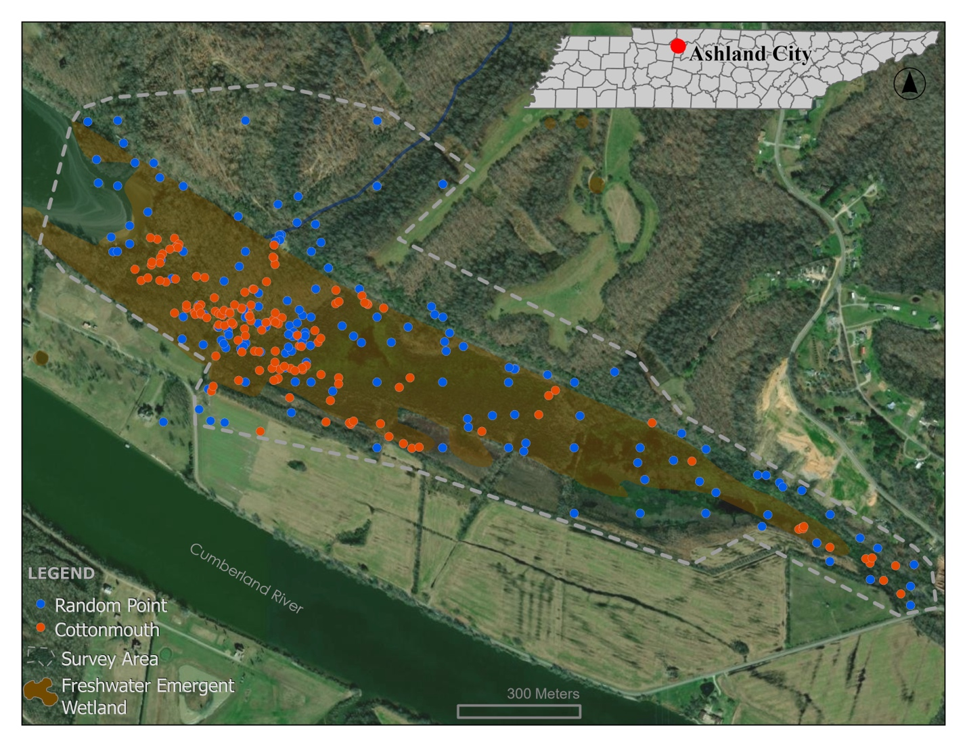
Figure 1. Map of the study area near Ashland City, Tennessee showing locations of Cottonmouth captures and randomly selected points for comparison of habitat features.

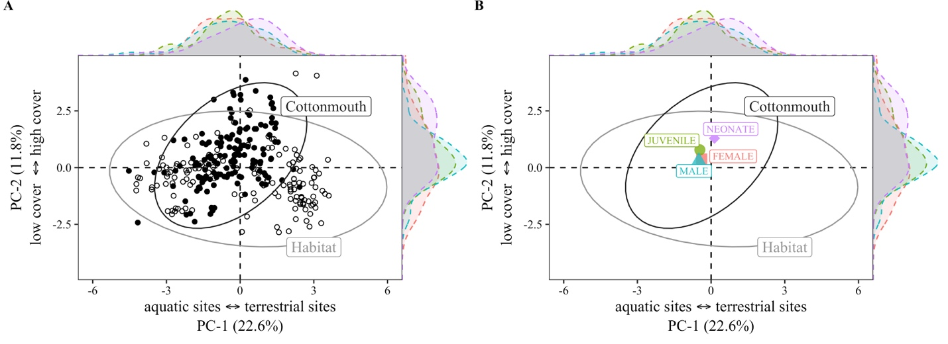
Figure 2. Principal Component Analysis (PCA) combining 16 environmental variables measured for Agkistrodon piscivorus (Cottonmouth) and available habitat comparison sites. A) Ellipses represent 95% confidence intervals for Cottonmouth (black) and available habitat (open circle). B) Symbols show mean component scores of the intra-specific groups; adult males (blue), adult females (red), juveniles (green), and neonates (purple). Point density curves for conspecific groups are represented for PC-1 (above), and PC-2 (right). PCA shows that Cottonmouths share broad similarities with the available habitat comparison sites, while neonates expressed some degree of separation from the other groups.

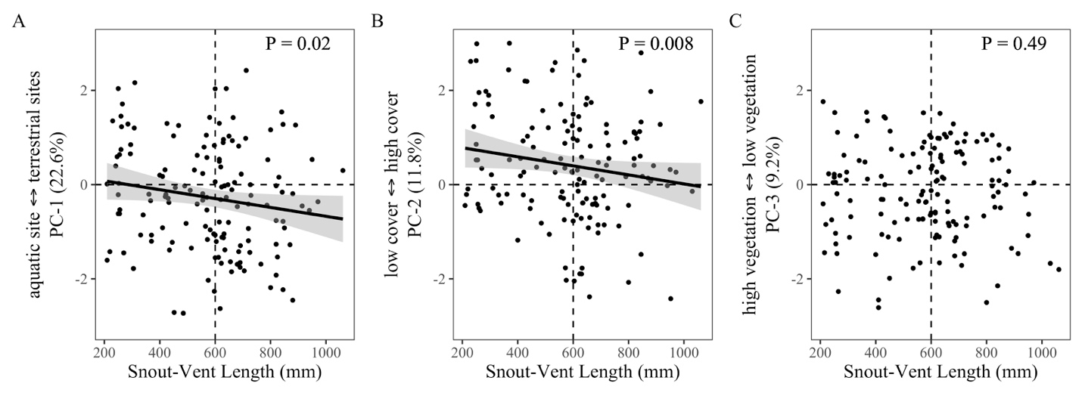
Figure 3. Linear Regression of Principal Component scores showing ontogenetic shift in habitat selection as a function of body size (snout-vent length). Linear Regressions show a significant negative slope for PC-1 and PC-2 expressing an ontogenetic shift in the population, however there was no relationship of an ontogenetic shift on PC-3.

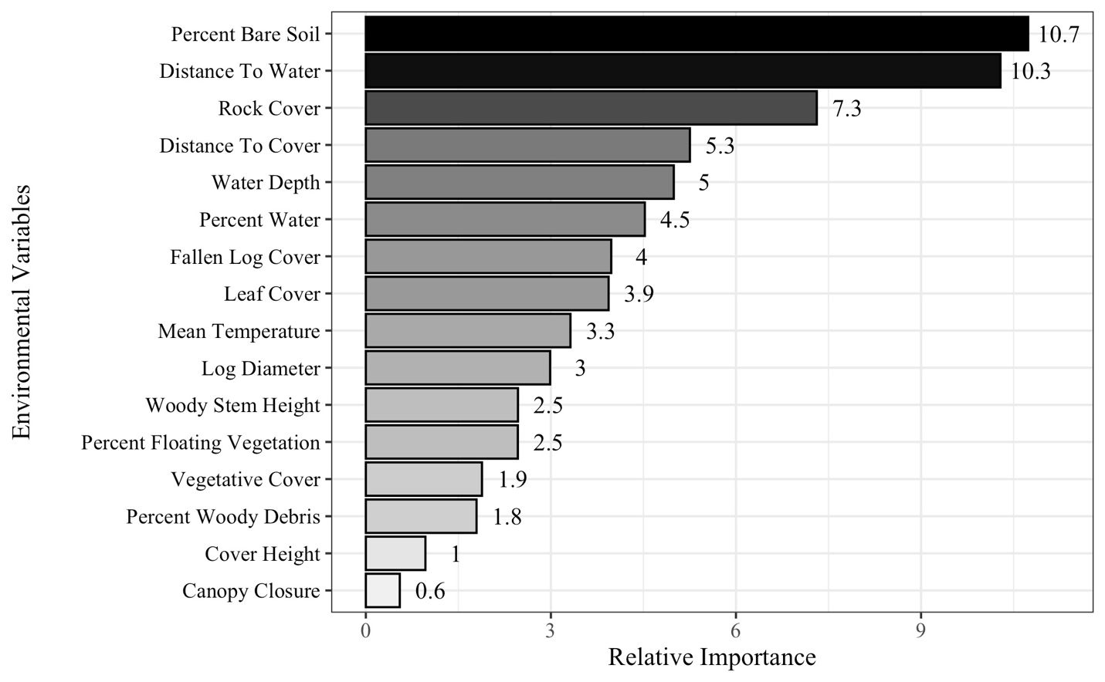
Figure 4. The relative importance of environmental variables related to Cottonmouth (Agkistrodon piscivorus) habitat selection based on the Mean Decrease Accuracy in the minimum error rate Random Forest Model. The six most predictive environmental variables described occurrence sites within the transitional gradient between terrestrial and aquatic habitats.

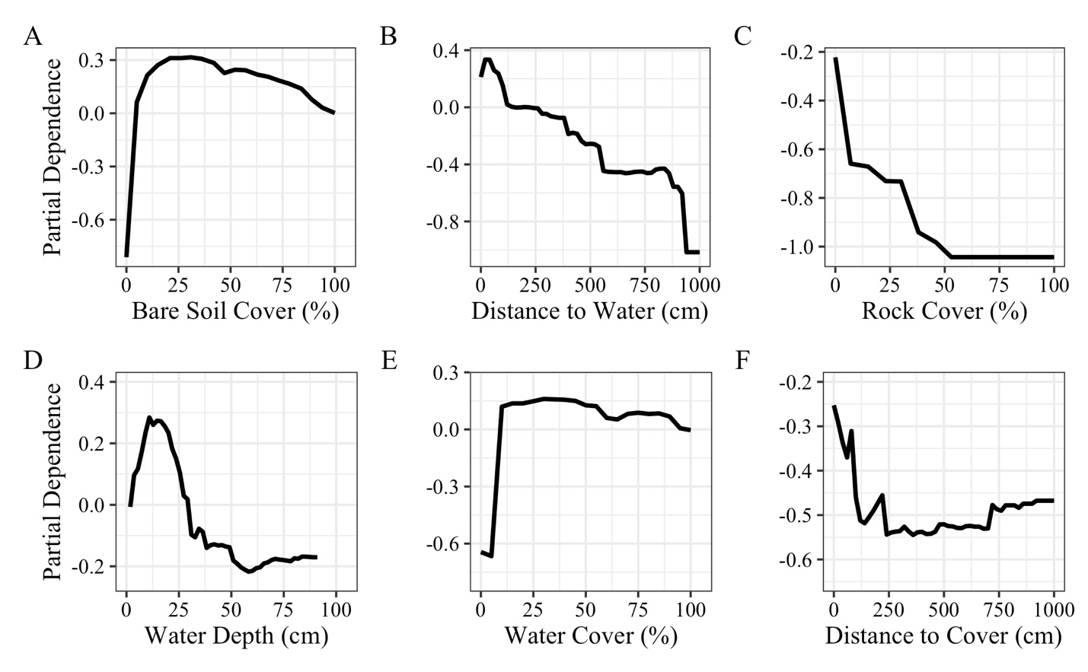
Figure 5. Centered partial dependence plots for Cottonmouth occurrences show nonlinear associations for the six most important contributing variables (based on mean decrease accuracy).

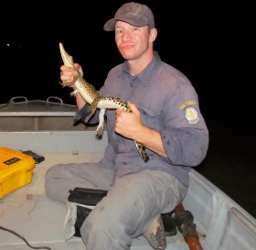

C.M. Gienger is a Professor in the Department of Biology and a Principal Investigator in the Center of Excellence for Field Biology at Austin Peay State University. He received his M.S. and Ph.D. from the University of Nevada, Reno, working on Mojave Desert Gila Monsters. His recent work has focused on the ecology of squamates, crocodilians, and chelonians. (Photographed by Matt Brien).



John H. Kauphusman is a Biologist for Burns and McDonnell Biological Consulting and works throughout the U.S. Midwest on a variety of infrastructure projects helping to protect threatened and endangered species. He received his B.S. in Biology from Minnesota State University, Mankato, and a M.S. in Biology from Austin Peay State University. His research has focuses on ecology, wetlands, and herpetology. He is a certified biologist and member of The Wildlife Society. (Photographed by Kenan Lochmueller).

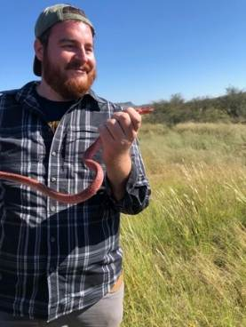

Michael C. Fulbright is an Assistant Professor at Cumberland University. He received his B.S. and M.S. degrees from Austin Peay State University. Michael has broad interests in biology, but his primary research interests include the physiological ecology and functional morphology of reptiles and amphibians. (Photographed by Raechelle L. Nye).

Supplemental Information
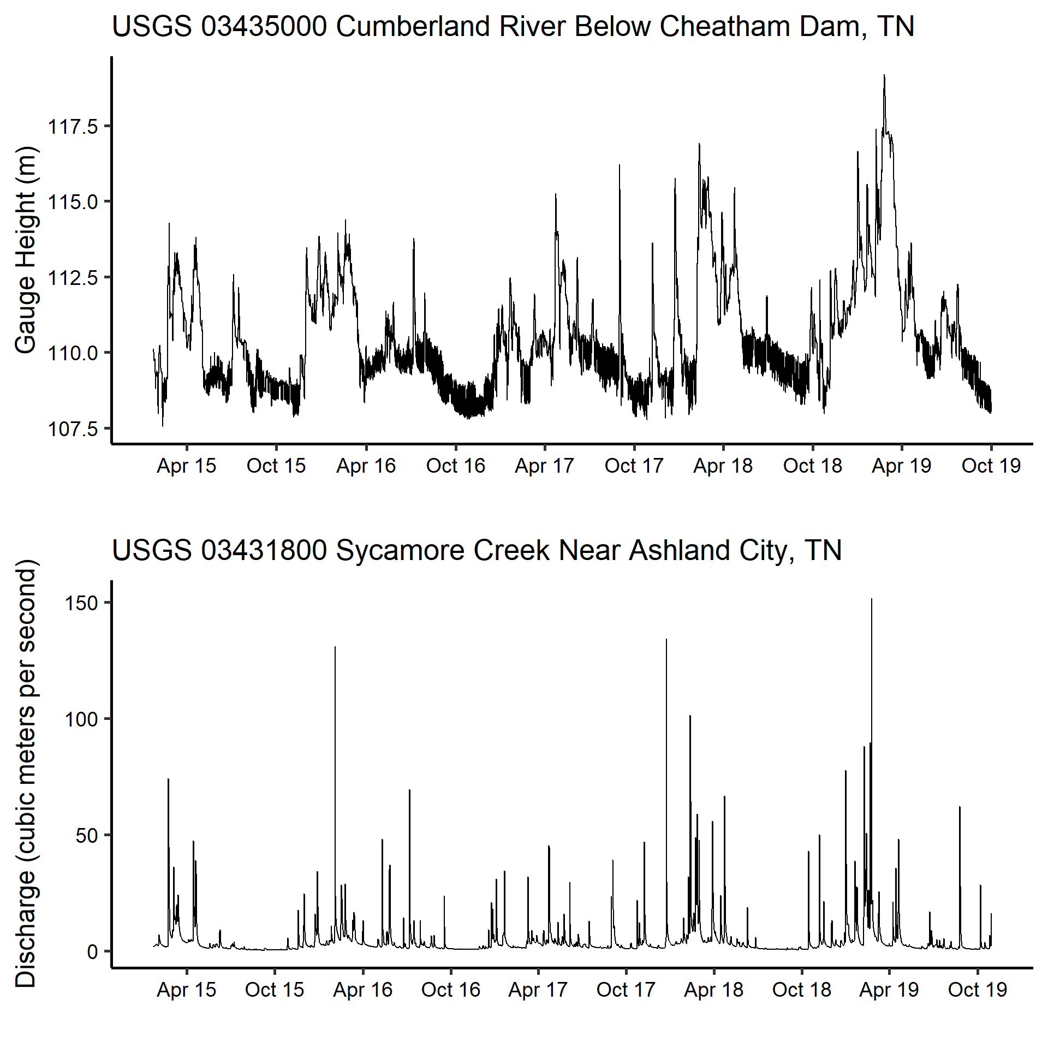
Supplemental Figure 1. (Above) Hydrographs of a five-year hydrologic cycle (from April 2015 to October 2019) of the Cumberland River below Cheatham Dam, Tennessee, USA, recorded at 36°19'22.26"N, 87°13'41.73"W, and Sycamore Creek Near Ashland City, Tennessee, USA and (Below) recorded at 36°19'11.89"N, 87°03'04.29"W. Both waterways flow into the riverine wetland slough. Information was provided by the USGS National Water Information System (https://waterdata.usgs.gov/nwis).

